 CHEMICAL ENGINEERING TRANSACTIONS  VOL. xxx, 2026 | A publication of  
The Italian Association
of Chemical Engineering
Online at www.cetjournal.it

Guest Editors: Flavio Manenti, Botir Usmonov, Alessandro Di Pretoro
Copyright © 2026, AIDIC Servizi S.r.l.
ISBN 979-12-81206-xx-x; ISSN 2283-9216

Tailoring the Surface Morphology and Photocatalytic Degradation of TiO₂/Iron Molybdate Composites

Dilshoda R. Tursunovaª* Zukhra С. Kadirova^{b}
ªTashkent Institute of Chemical Technology, Navoi Street 32A, Tashkent, Uzbekistan
^{b}Uzbek-Japan Innovation Center of Youth, University Street 2B, Tashkent, Uzbekistan
tursunovadilshoda54@gmail.com

The development of efficient light-driven photocatalysts is a critical frontier in materials science, particularly for addressing environmental remediation challenges through advanced oxidation processes. The aim of this study is to engineer the surface morphology of TiO₂ (T) through the incorporation of iron molybdate (Fe₂(MoO₄)₃ (FM)) via a precise solid-state thermal diffusion approach. Pure anatase TiO₂ was mixed with iron molybdenum precursors in various stoichiometric ratios (T1/FM1, T1.5/FM0.5, T1.75/FM0.25, and T1.9/FM0.1) and subjected to high-temperature annealing at 600 °C for 5 h. SEM analysis revealed a remarkable transformation in surface morphology, specifically at lower iron molybdate concentrations (T1.9/FM0.1). As the loading increased, these features evolved into complex, highly textured, agglomerated clusters with increased surface roughness and potential active sites. EDS mapping demonstrated a highly homogeneous distribution of titanium, iron, and molybdenum across the composite surface, confirming that the thermal diffusion method effectively integrates the secondary phase without undesirable segregation. Elemental analysis confirmed the chemical consistency of the composites, and the oxygen content was accurately determined via stoichiometric compensation based on the identified metallic oxides (TiO₂, Fe₂(MoO₄)₃). The photocatalytic performance was tested by measuring the degradation of nitrofurazone under solar irradiation in aqueous solution. The results confirmed that the tailored surface morphology and the Fe₂(MoO₄)₃/TiO₂ heterojunction significantly suppressed the recombination of photogenerated electron-hole pairs, thereby enhancing degradation efficiency relative to pristine TiO₂. The optimized T1.9/FM0.1 sample exhibited the highest activity, suggesting that the synergistic combination facilitates efficient charge-carrier separation.
1. Introduction
The rapid escalation of industrial activities and the subsequent discharge of complex organic micro-pollutants into aquatic ecosystems have emerged as a global environmental crisis (Li et al., 2021). Traditional wastewater treatment technologies often struggle to degrade persistent organic compounds, requiring the development of advanced oxidation processes (AOPs) (Mammadov et al., 2017). Among these, semiconductor-based heterogeneous photocatalysis has gained significant attention as a sustainable and cost-effective remediation strategy (Lettieri et al., 2021). Titanium dioxide (TiO₂), particularly in its anatase phase, remains the most widely investigated photocatalyst due to its exceptional chemical stability, non-toxicity, and high photo-oxidative potential (Li et al., 2021). Despite these advantages, the practical application of pristine TiO₂ is severely constrained by its wide intrinsic bandgap (E_{g} = 3.2 eV), which limits activation to the ultraviolet spectrum, and the rapid recombination of photogenerated electron-hole pairs (Cabezuelo et al., 2023). Recent research has demonstrated that these limitations can be overcome through interface engineering. Specifically, the construction of heterojunctions by coupling TiO₂ with narrow-bandgap semiconductors, such as iron-based molybdates, has proven effective in extending light absorption and enhancing charge carrier separation (Li et al., 2021). Radical intermediate studies using EPR spin-trapping have further confirmed that such heterostructures facilitate the generation of highly reactive species, specifically hydroxyl (.OH) and superoxide (O₂^{.-}) radicals, which are crucial for the mineralization of organic pollutants (Dvoranova et al., 2014). Furthermore, the efficiency of photocatalytic reactions is profoundly influenced by the catalyst's morphology (Montoya-Bautista et al., 2019). Tailoring the surface properties and shape of TiO₂ nanoparticles allows for the optimization of active site exposure and light-harvesting capabilities (Torelli, 2015, Yeung et al., 2003). Beyond performance, the sustainability of photocatalyst production has become a key focus. The valorization of industrial solid wastes as secondary precursors for synthesizing high-value materials (Sugranez et al., 2013), such as molybdenum-based oxides, aligns with the principles of the circular economy, reducing both production costs and environmental footprints (Tursunova et al., 2025a). Among various pollutants, Nitrofurazone (NFZ), a broad-spectrum nitrofuran antibiotic, has raised significant ecological concerns due to its persistence and potential carcinogenic effects. Recent investigations have highlighted the necessity of developing efficient photocatalytic systems specifically tailored for the rapid mineralization of NFZ using mixed-oxide composites (Laoufi et al., 2013, Tursunova et al., 2025b).
In this study, a novel approach is reported for tailoring the surface morphology of TiO₂/Fe₂(MoO₄)₃ composites synthesized via a precise thermal diffusion route. Unlike conventional liquid-phase methods, this approach yields a robust, well-defined heterojunction interface. This work specifically investigates the structural transition from TiO₂ spherical microstructures to highly textured Fe₂(MoO₄)₃ clusters and evaluates their synergistic effect on the solar-light-driven degradation of Nitrofurazone.
2. Materials and Methods
2.1. Raw Materials and Reagents
In this study, industrial solid waste was used as the primary precursor for synthesizing composite photocatalysts. Metallurgical solid waste obtained from the Almalyk Mining and Metallurgical Complex (AMMC) served as the source for iron molybdate (FM), while industrial waste from the Shurtan Gas Chemical Complex was employed as the source for titanium dioxide (TiO₂). All other chemical reagents used for pH adjustment and cleaning were of analytical grade and used without further purification.
2.2. Synthesis of Photocatalytic Materials from Industrial Waste
The industrial solid wastes were first processed in a ball mill to obtain a fine powder. To investigate the effect of composition on photocatalytic performance, the powdered precursors were mixed in various stoichiometric ratios. In these formulations, TiO₂ was maintained as the primary matrix (T), while the mass fraction of iron molybdate (FM) was systematically decreased. To synthesize the composites, the prepared mixtures were subjected to solid-state thermal treatment in a muffle furnace at 600 °C for 5 h. This thermal diffusion process facilitated the phase formation of iron molybdate (Fe₂(MoO₄)₃) and the creation of a robust heterojunction interface with the TiO₂ support. Based on the weight ratios of TiO₂ to Fe₂(MoO₄)₃, the synthesized composites were labelled as T1/FM1, T1.5/FM0.5, T1.75/FM0.25, and T1.9/FM0.1.
2.3. Photocatalytic Activity Testing
The photocatalytic efficiency of the synthesized samples (T1/FM1, T1.5/FM0.5, T1.75/FM0.25, and T1.9/FM0.1) was evaluated by degrading nitrofurazone in an aqueous solution under UV light irradiation. Specifically, a 0.01 mol/L nitrofurazone solution was used as the model pollutant. For each experiment, 1 g of the catalyst was dispersed into 100 mL of the pollutant solution. Prior to light exposure, the suspension was stirred in the dark for 30 min to establish adsorption-desorption equilibrium. The photocatalytic degradation experiments were carried out under irradiation using a commercial Asahi HAL-321 Solar Simulator equipped with a 300 W compact xenon lamp (wavelength range: 350 nm - 1200 nm) placed inside a custom-built reaction chamber (power density 100 mW cm⁻², exposed area 3×3 cm²). At predetermined time intervals, aliquots were collected, and changes in pollutant concentration were monitored using a UV-fluorescence spectrometer (Duetta, Horiba, Japan). The photodegradation rate constant (k_{app}) was calculated using the pseudo-first-order kinetic model of Langmuir-Hinshelwood, expressed by the following equation:
$$\ln\left(\frac{C_{0}}{C}\right)=k_{app} · t$$
where C₀ is the initial concentration of the pollutant after equilibrium (mol/L), C is the concentration at irradiation time t (mol/L), and k_{app} is the apparent rate constant (min⁻¹).
2.4. Physicochemical Characterization
The structural and morphological properties of the composites were analyzed using the following techniques:
- SEM/EDS: Scanning Electron Microscopy (SEM) coupled with Energy-Dispersive spectroscopy (EDS) was employed to examine the surface morphology and the elemental distribution (SEM mapping) across the catalyst surface (Phenom, ThermoFisher, USA).
- UV-vis Spectrophotometry: This technique was utilized to monitor the photocatalytic kinetics during the degradation of organic compounds and dyes in wastewater, providing insights into the reaction rates and efficiency (Duetta, Horiba, Japan).
3. Results and discussion
The physicochemical properties and photocatalytic performance of the synthesized TiO₂/Fe₂(MoO₄)₃ composites are systematically evaluated. Table 1 data confirms that the weight percentages (wt. %) of Ti, Mo, and Fe align precisely with the experimental precursor ratios used during synthesis. Notably, in the optimized T1.9/FM0.1 sample, the Mo (3.8%) and Fe (0.7%) concentrations are at their minimum, supporting the formation of a highly dispersed active layer on the TiO₂ support.
Table 1: Elemental composition (wt. %) of TiO₂/Fe₂(MoO₄)₃ composites determined by EDS analysis.
Samples | Ti (wt. %) | Mo (wt. %) | Fe (wt. %) | O (wt. %)
T1/FM1 (Sample 2) | 22.1 | 19.6 | 5.5 | 52.8
T1.5/FM0.5 (Sample 3) | 40.5 | 15.3 | 5.5 | 38.7
T1.75/FM0.25 (Sample 4) | 52.1 | 7.1 | 1.6 | 39.2
T1.9/FM0.1 (Sample 5) | 61.2 | 3.8 | 0.7 | 34.3

The surface morphology and textural properties of the synthesized TiO₂/Fe₂(MoO₄)₃ heterostructured composites are shown in Figures 1. The micrographs reveal that the composites consist of irregularly shaped microparticles with varying degrees of agglomeration depending on the precursor ratios. For samples 2-3 with a higher iron molybdate content, such as T1/FM1 and T1.5/FM0.5, significant particle clustering and large agglomerates are observed (Figure 1a-c). Such dense morphologies typically reduce the effective specific surface area and may decrease the number of active photocatalytic sites, consequently limiting overall efficiency. In contrast, reducing the Fe₂(MoO₄)₃ fraction to a ratio of 0.1 (T1.9/FM0.1) leads to transformation in the surface architecture (Sample 5). As shown in the high-magnification micrograph (Figure 1d, 3100x), the particles exhibit a highly dispersed state, uniformly distributed throughout the TiO₂ matrix. This fine morphology enhances porosity and increases the number of available active sites, which is crucial for the effective adsorption of organic pollutants like nitrofurazone.
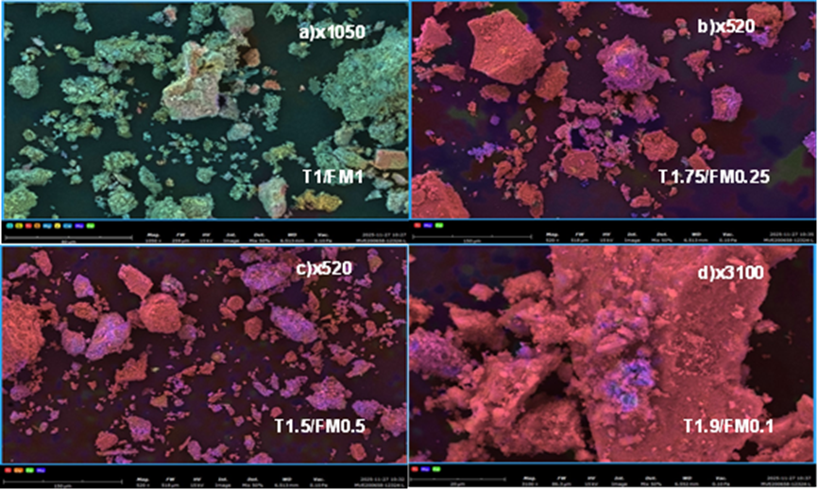
Figure 1: SEM micrographs and corresponding EDS elemental mapping of synthesized TiO₂/Fe₂(MoO₄)₃ heterostructured composites: (a) T1/FM1, (b) T1.5/FM0.5, (c) T1.75/FM0.25, and (d) T1.9/FM0.1.
Figures 2a-d confirm that the composites consist predominantly of titanium dioxide (TiO₂) and iron molybdate (Fe₂(MoO₄)₃) phases. The relative peak intensities vary with the Ti/Mo ratio; for Sample 5 (T1.9/FM0.1) (Figure 2d), the Ti peak is at its maximum, while the Fe and Mo peaks are minimal. The color-coded maps show a highly homogeneous distribution of titanium (Ti), iron (Fe), and molybdenum (Mo). The overlap among these elements indicates that the Fe₂(MoO₄)₃ phase is not mechanically mixed but has formed a heterojunction interface with the TiO₂ support. The contact between the two semiconductors facilitates a synergistic effect, promoting the separation of photogenerated electron-hole pairs and suppressing their recombination. The superior morphological features of the T1.9/FM0.1 sample directly correlate with the maximum apparent rate constant (kapp) observed in the photocatalytic degradation tests (Figure 4).
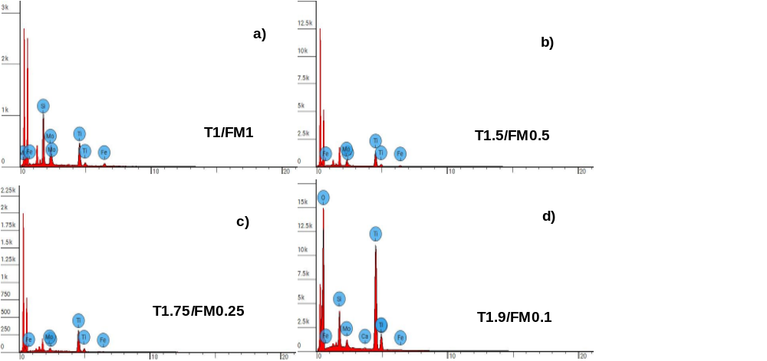
Figure 2: EDS spectra of synthesized TiO₂/Fe₂(MoO₄)₃ heterostructured composites with different Ti/Mo ratios: (a) T1/FM1, (b) T1.5/FM0.5, (c) T1.75/FM0.25, and (d) T1.9/FM0.1, confirming chemical purity and phase stoichiometry.
The SEM-EDS results are corroborated by DRS spectra (Figure 3a), which confirm the chemical integrity and phase distribution within the composites. Sample 5 (T1.9/FM0.1 composite) exhibited optimal photocatalytic performance under solar light, which consists mainly of visible light (Figure 3, 4a). The DRS spectrum of Sample 5 is closer to the iron molybdate (FM) baseline, showing lower reflectance and higher visible-light absorption. This also indicates structural integration of titanium dioxide (T) and FM phases, as well as red-shift/visible-light activation. Compared to pristine T, the composite’s reflectance drops drastically in the 400–600 nm range. This confirms that coupling T with FM significantly enhances its visible-light absorption capability. The peak around 750 nm, followed by a localized absorption dip near 850 nm, might be attributed to complex optical transitions, sub-bandgap states, or specific surface/interfacial electronic interactions between the TiO₂ matrix and the iron molybdate clusters.
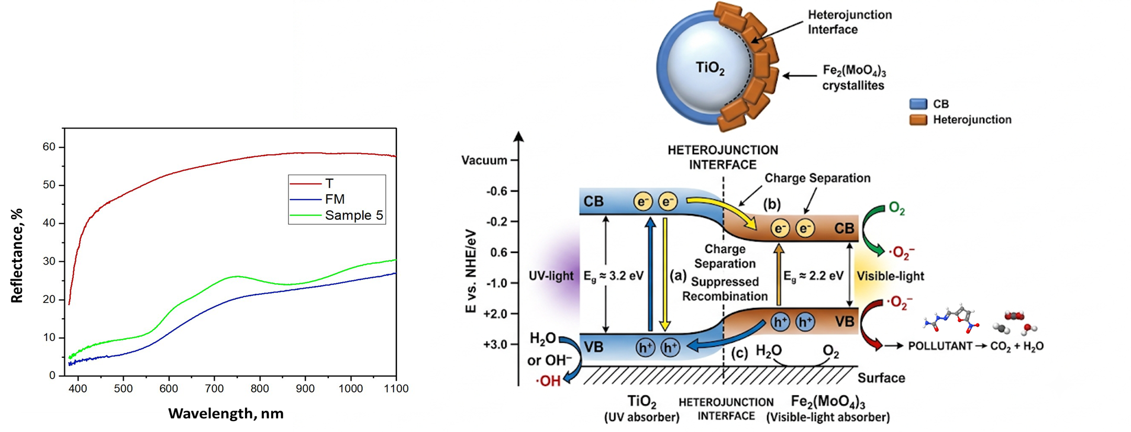
a b
Figure 3: DRS-spectra (a) and (b) Type II Heterojunction mechanism
The particle distribution is free of agglomeration, ensuring maximal exposure of active surface sites. The Type II Heterojunction mechanism is based on the uniform, highly homogeneous distribution of Ti, Mo, and Fe across the composite surface at both micron and submicron scales. Such a high degree of dispersion and robust connectivity act as an “electronic bridge,” facilitating efficient contact with the nitrafurazone molecule and promoting the separation of photogenerated electron-hole pairs, finally lowering recombination. This correlates directly with photocatalytic activity (k_{app}), indicating that the optimized stoichiometry maximizes the synergistic effect between the two semiconductors (Figure 3b).
The photocatalytic degradation mechanism of nitrofurazone (NFZ)—a synthetic nitrofuran antibiotic—involves a series of non-selective, multi-step advanced oxidation and reduction pathways initiated by reactive oxygen species and photogenerated holes.

Nitrofurazone + OH /O₂⁻ / h⁺ →intermediates→CO₂ + H₂O + NO₃⁻ + NH₄⁺

The relationship between the mass ratio of T/FM components and the resulting apparent rate constant (k_{app}) is illustrated in Figure 4. The data reveal a non-linear correlation, indicating that the photocatalytic efficiency is highly sensitive to the stoichiometric balance between TiO₂ and Fe₂(MoO₄)₃. While pristine TiO₂ (Sample 6) and Fe₂(MoO₄)₃ (Sample 1) exhibit baseline activities, the heterostructured composites show a significant enhancement in performance. Specifically, Sample 5 (T1.9/FM0.1) achieved the highest photocatalytic activity with k_{app} = 0.0928 min⁻¹. This peak efficiency is attributed to the optimal synergy between the two semiconductors at this specific ratio. The significant increase in k_{app} for Sample 5 correlates directly with the high-dispersion morphology observed in the SEM analysis (Figure 1 d), which provides a larger effective surface area for nitrofurazone adsorption. Furthermore, the mismatch between the theoretical efficiency for a simple mixture of T and FM (purple line) and the experimental results (green line) suggests that performance is governed not only by the bulk quantities of the materials but also by the quality of the heterojunction interface, which facilitates efficient charge-carrier separation and minimizes recombination losses.
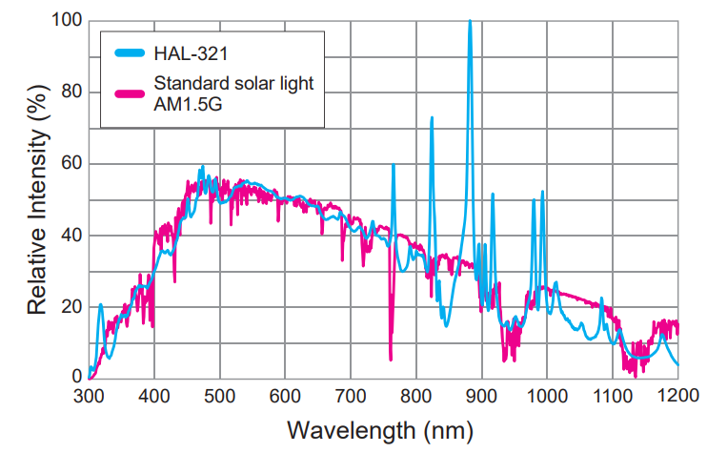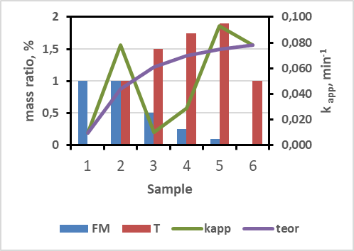
a b
Figure 4: Spectral range of light for photocatalytic tests [https://www.asahi-spectra.com/opticalinstrument/hal321.asp] (a) and the correlation between the mass ratio of T (TiO₂) and FM (Fe₂(MoO₄)₃) and the apparent photocatalytic rate constant (k_{app}) of the synthesized composites (b).

Thus, the maximum apparent rate constant (kapp) observed for Sample 5 correlates with superior performance, attributed to the idealized morphology and a robust interphase heterojunction.
Conclusion
In this study, high-performance TiO₂/Fe₂(MoO₄)₃ heterostructured photocatalysts were synthesized from industrial wastes. The results demonstrate that the stoichiometric ratio of the components is a decisive factor in determining the morphology and photocatalytic activity of the resulting materials. Comprehensive SEM and EDS mapping analyses confirmed that the T1.9/FM0.1 ratio yields superior particle dispersion and promotes the formation of a robust interphase heterojunction. According to the photocatalytic evaluations, the composite (Ti 61.2, Mo 3.8, Fe 0.7 mass. %) exhibited the highest apparent rate constant (k=0.0928 min-1) for the degradation of nitrofurazone and methylene blue, outperforming pristine TiO₂ and other composite variations. Consequently, the prepared composite demonstrates exceptional efficiency in degrading hazardous antibacterial pollutants, offering a cost-effective pathway for environmental protection through waste valorization and a sustainable, scalable strategy for modern wastewater treatment.
Acknowledgments
The authors would like to express their sincere gratitude to the Uzbekistan-Japan Innovation Center of Youth (UJICY) for providing the laboratory facilities and technical assistance during the SEM and EDS characterizations. The authors also acknowledge the Tashkent Institute of Chemical Technology (TICT) for their institutional and administrative support throughout this doctoral research.
References
Cabezuelo O., Ponce-Gonzalez L.N., Marin M.L., Bosca F., 2023, A highly efficient supported TiO₂ photocatalyst for wastewater remediation in continuous flow, Applied Materials Today, 35, 101947, 1-12.
Dvoranova, D., Barbierikova, Z., Brezova, V., 2014, Radical Intermediates in Photoinduced Reactions on TiO₂ (An EPR Spin Trapping Study), Molecules, 19, 17279-17304.
Laoufi, N., Hout S., Tassallit D., Ounnar A., Djouadi A., Chekir N., Bentahar F., 2013. Removal of a persistent pharmaceutical micropollutant by UV/TiO₂ process using an immobilized titanium dioxide catalyst: parametric study. Chemical Engineering Transactions.
Lettieri S., Pavone M., Fioravanti A., Santamaria Amato L., Maddalena P., 2021, Charge Carrier Processes and Optical Properties in TiO₂ and TiO₂-Based Heterojunction Photocatalysts: A Review, Materials, 14, 1645, 1-57.
Li K., Teng C., Wang S., Min Q., 2021, Recent Advances in TiO₂-Based Heterojunctions for Photocatalytic CO2 Reduction With Water Oxidation: A Review, Frontiers in chemistry, 9, 637501, 1-25.
Mammadov G., Ramazanov M., Kanaev A., Hasanova U., Huseynov K., 2017. Photocatalytic degradation of organic pollutants in air by application of titanium dioxide nanoparticles. Chemical Engineering Transactions, 60, 241-246.
Montoya-Bautista C. V., Avella E., Ramirez-Zamora R. M., Schouwenaars R., 2019, Metallurgical Wastes Employed as Catalysts and Photocatalysts for Water Treatment: A Review, Sustainability, 11, 2470, 1-16.
Sugranez R., Cruz-Yusta M., Marmol I., Morales J., Sanchez L., 2013, Preparation of sustainable photocatalytic materials through the valorization of industrial wastes, ChemSusChem, 6, 2340–2347.
Torelli S., 2015, Morphological control of TiO₂ anatase nanoparticles: What is the good surface property to obtain efficient photocatalysts? Applied Catalysis B: Environmental, 174-175, 350-360.
Tursunova D.R., Kadirova Z.C., Daminova S.S., Gabidullina K.K., 2025a, Photocatalytic activity of the mixed of Ti/Fe/Mo oxide composites for degradation of nitrofurazone, Chemistry and Chemical Engineering, 2025, 4, 38-63.
Tursunova D.R., Daminova S.S., Nusretov R.A., Shiknazarov A., Kadirova Z.C., 2025b, Effect of desorption on photocatalytic decomposition of methylene blue using materials from solid wastes of production of molybdenum oxides (VI) and titanium dioxide, Chemistry and Chemical Engineering, 2024, 4, 54-64.
Yeung K.L., Yau S.T., Maira A.J., Coronado J.M., Soria J., Yue P.L., 2003, The influence of surface properties on the photocatalytic activity of nanostructured TiO₂, Journal of Catalysis, 219, 107–116.

